Randy Pennington’s Favorite Songs About Change
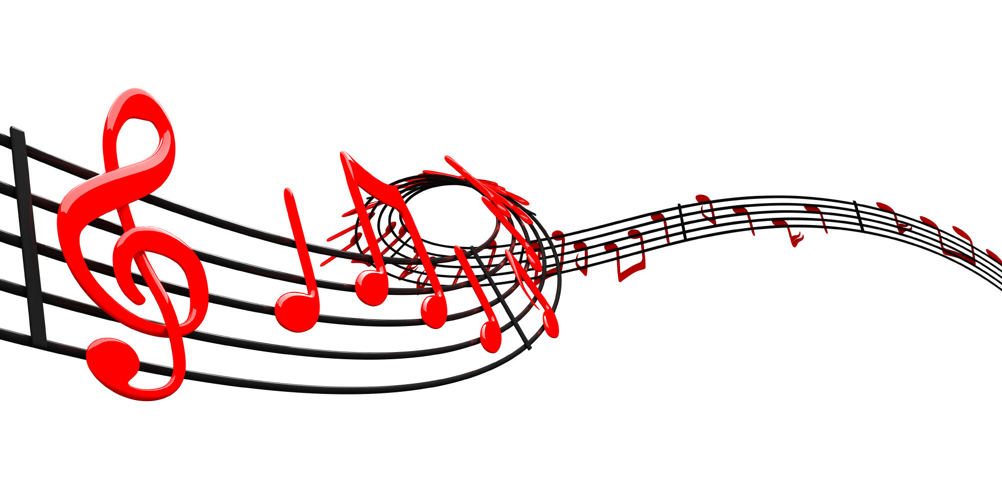

Artist | Title |  | You Tube Link*
Eric Clapton |  | Change the World |  | http://www.youtube.com/watch?v=kntzQiaFzOQ
David Bowie |  | Changes |  | http://www.youtube.com/watch?v=zbnJo88kuP8
REO Speedwagon |  | Roll With the Changes |  | http://www.youtube.com/watch?v=JBadNvkmjtY
Sam Cooke |  | A Change Is Going to Come |  | http://www.youtube.com/watch?v=j-X9JkM9Bgo
Bob Dylan |  | The Times They Are A Changing |  | http://www.youtube.com/watch?v=AH8hPRCr72w
Tracy Chapman |  | Change |  | http://www.youtube.com/watch?v=drXwsVYrd20
Kylie Rae Harris |  | Change |  | http://www.youtube.com/watch?v=vUYWHz0gVqM
Carrie Underwood |  | Change |  | http://www.youtube.com/watch?v=2H0EY4Rrpf4
Taylor Swift |  | Change |  | http://www.youtube.com/watch?v=5Zp_3QcNPD0
Elvis Costello and She & Him |  | Change is Hard |  | http://www.youtube.com/watch?v=oE7D7DYFrLA
Scorpions |  | Wind of Change |  | http://www.youtube.com/watch?v=rMUX_4B-Hr4
John Waite |  | Change |  | http://www.youtube.com/watch?v=ocM12tYGeqg
Tears for Fears |  | Change |  | http://www.youtube.com/watch?v=YZWAqZN-uJo
Blind Melon |  | Change |  | http://www.youtube.com/watch?v=R5mjntMAfbU
The Gandhi Rap |  | Be the Change |  | http://www.youtube.com/watch?v=1Qd-fAnHjPg
Jana Stanfield |  | Let the Change Begin  If I Were Brave |  | http://www.youtube.com/watch?v=eE0jB1OuAQw  http://www.youtube.com/watch?v=ipy9bW-P8dE
* No copyright ownership implied nor infringement intended. These links are for reference to introduce others to the artist and song.

